**Sample Meeting Minutes**

**Team**: SMV – Smart Q& A **Date**: January 18, 2018

**Facilitator**: Christina Mara

**Recorder**: Will Rea

**Attendance**:

|  |  |
| --- | --- |
| Christina Mara  Will Rea  Matt Rosenbloom  Zach Brownlow | Ignacio Dominguez  Margaret Heil  Robert Fornaro |

**Minutes:**

Meeting started out with introductions of attendees

Christina explains the students’ understanding of the project thus far. We are expecting that there will be a lot of research involved.

Dr. Fornaro explains that he thinks our first priority for the project should be building the system and then we can look in to different NLP libraries.

**Question and Answer time with Dr. Fornaro and Ignacio Dominguez**

The only main constraint given for the project is that a PHP back end will receive a question and then send the question to our portion of the project. We will not have access to the PHP system so we will have to create our own. Ignacio shared a picture to help illustrate the way the system will work.

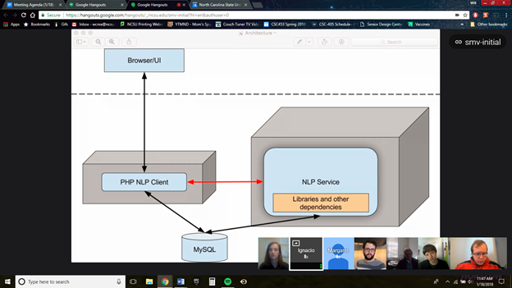

Right now all of the data that the company has is stored in a MySQL database which contains both questions and answers to a single subject.

SMV was conceived based on the founder who had a lot of experience with instructional videos on a corporate level. The idea is to improve the transfer of knowledge by including some interactivity in the system. It sounded like the company would be dealing with mostly corporate clients.

At first they want the system to be able to match frequently asked questions with pre-given answers, but as a long term goal they hope to be able to identify questions given a subject matter and enough information about the topic.

An individual answer may be 3 to 4 sentences long and there may only be about 50 answers total. At the beginning we will be given a list of frequently asked questions along with the answers to those questions, which will make testing easier.

Storing the data using a MySQL database is not a constraint, however we can store the data however we see fit.

Some libraries may require us to preprocess data and quick access to the data is important, if it takes too long to access the list of answers then the system is not working as intended.

A **Stretch Goal** would be for the system to suggest another question if a question without an answer is given.

Dr. Fornaro suggested that we start as simply as possible with a list of FAQs and the corresponding answers. In this way it is easy to tell when the system returns the correct answer. After the system is working correctly when given predefined questions we can move on to undefined questions.

We will only need the system to function in English.

Dr. Fornaro said that a long term goal would be to be able to give the system a block of text from a textbook and then have it determine an answer to a question given the information it has already learned.

As an intermediate step it will make sense for us to show the data we are working with, such as if two answers have similar probabilities for being correct.

Both Dr. Fornaro and Ignacio recommended that we use the Natural Language ToolKit (NLTK) from Python. Ignacio included a link to a book. <http://www.nltk.org/book/>

Most likely they will not want two responses. If two responses are deemed viable, then the system should randomly choose one to return to the user.

Dr. Fornaro wanted to make it clear that we needed to better distinguish between requirements for the project and tasks for the team. There were a lot of questions that seemed task oriented and not requirement oriented.

The team described that we were expecting that there would be a lot of acceptance/black box testing. Dr. Fornaro agreed, but said there may need to be some unit testing for the code that we write.

Everyone decided that meeting once a week was a good starting point. We will be meeting on Thursdays from 11:30-12:30 in the Senior Design Center.

We will receive the data that SMV already has in the form of a MySQL database. They are hoping to have that available to us by the meeting on Thursday, January 25th.

|  |  |  |
| --- | --- | --- |
| **Action Item** | **Person Responsible** | **Due Date** |
| Dr. Fornaro said he would be looking for some diagrams? I’m not exactly sure what he meant by that. | Team | 1/25 |
| Requirements Document (Rough Outline) | Team | 1/25 |
| Something simple using the API, Ignacio suggested identifying the parts of speech of different words in a sentence. | Team | 1/25 |
| Each team member is to individually install the toolkit and read through the first chapter of the book at <http://www.nltk.org/book/> | Team | 1/25 |

**Meeting Evaluation: Positive -** Learned quite a bit. **Negative -** It was difficult to understand people at times because of connection issues with Google Hangouts

**Next Meeting: <**Thursday, January 25, 2018 at 11:30 am> Show off what we have learned about NLTK